Academia San Agustín y Espíritu Santo
_{De Sabana Grande}

Mrs. Martinez Weekly Agenda Subject to changes
English | Date | REVIEW FOR FINALS | 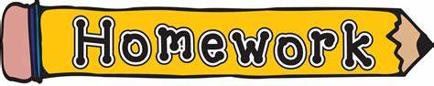
W  E  E  K  #41 | Monday  May 11, 2020 | Community Helpers  - Students are to find vocabulary words related to community helpers in a word search. | See page 2/6 below
 | Tuesday  May 12, 2020 | Making Connections: Three Types of Communities  - Students are to learn to define, identify and the differences between Urban, Suburban, & Rural Communities. | Use your notebook to answer questions in TB p. 179
 | Wednesday  May 13, 2020 | Making Connections: Three Types of Communities  - Students are to watch the Rural, Suburban, and Urban movie and write down the definition for the three types of communities.  Go to Urban, Suburban, and rural communities for kids classroom video (10 min. video) | Three worksheets are provided below for this activity. see pages  3/6, 4/6, & 5/6 below  Don’t forget to send in all the pages above 2/6 through 5/6 and answers from TB p. 179 on Thursday, May, 14, 2020!
 | Thursday  May 14, 2020 | Making Connections: Where do you live?  - Students are to learn where he/she lives. | Live Audio Assessment: TO BE MEMORIZE!! see below 6/6
 | Friday  May 15, 2020 | Making Connections: Where do you live?  - Students are to continue working with their activity above. | Send in this special activity on Tuesday, May 19, 2020.

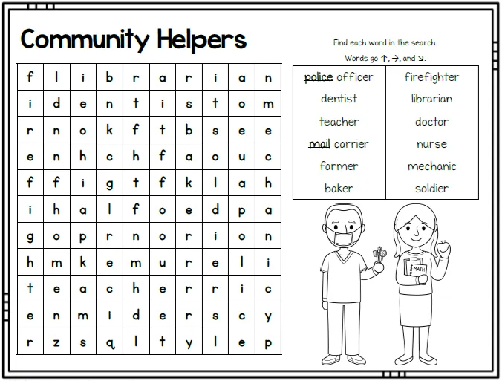

__________________________________________________Community
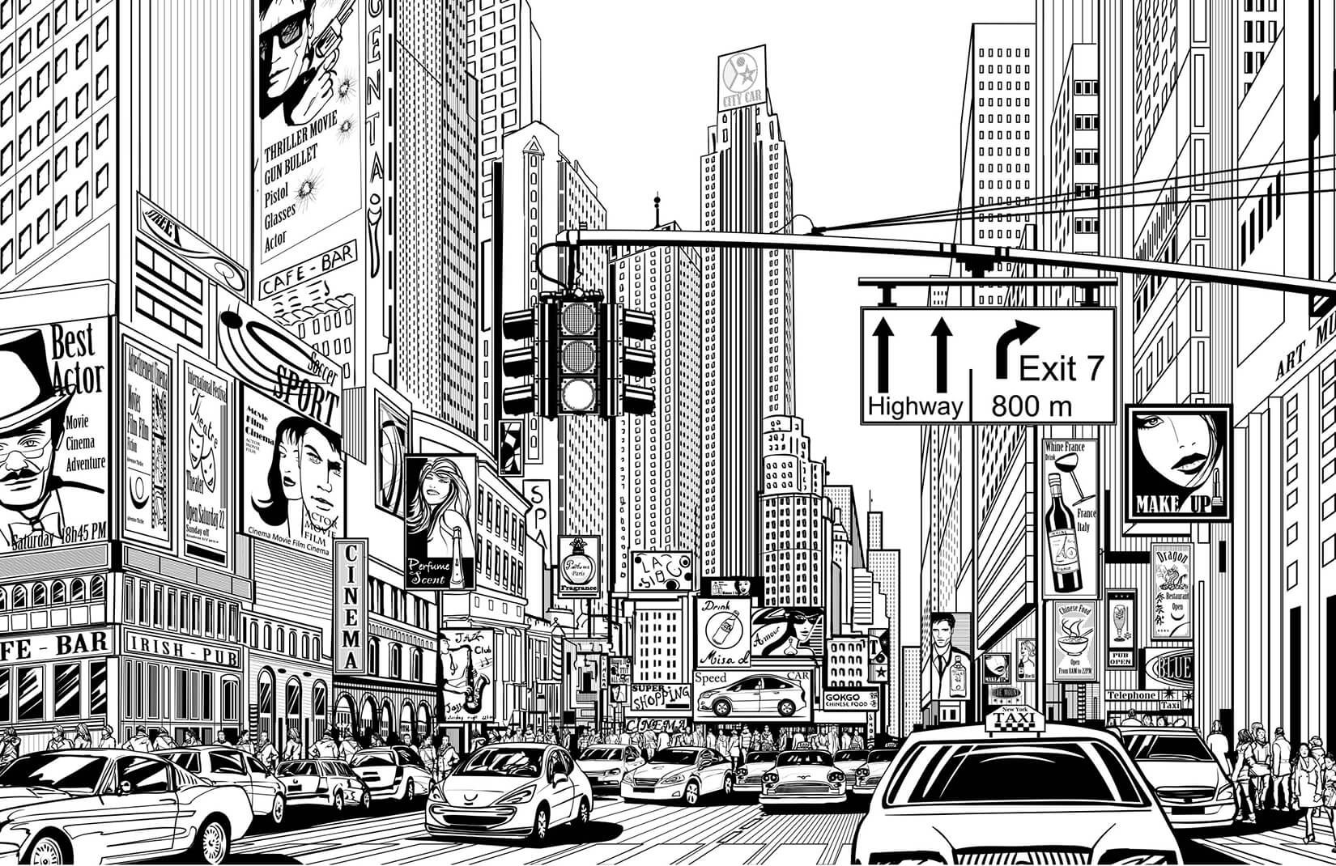

__________________________________________________Community
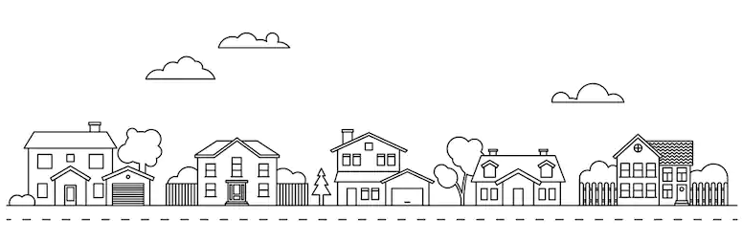

__________________________________________________Community

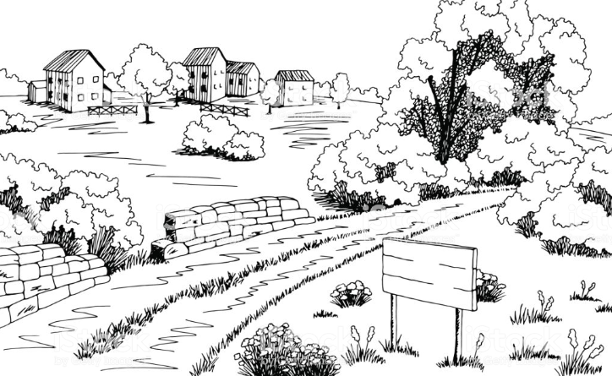

Where I live

Directions:
Step 1. Make a welcome sign for your community include the name of your community. BE CREATIVE!
Step 2. Draw a picture of your community and label your community as Urban, Suburban, or Rural.
Step 3. Copy and complete the blanks with your information.
Hi! My name is ______. I live in __________. I like living here because _______________. My home address is
________. My favorite place in _________is _____________. Some important places where I live are (list at
least 4)______, _______, ________, and ________. I love my community.
Step 4: Activity is due on Tuesday, May 19, 2020
Step 5: Student is to review daily until he/she memorizes the important information.
Step 6: Record your child for a Live Audio Reading Assessment

