Academia San Agustín y Espíritu Santo
_{De Sabana Grande}

Mrs. Martinez Weekly Agenda Subject to changes
English | Date | Class Assignment
W  E  E  K  #36 | Monday  April 6, 2020 | Connect Between the Education and Facebook  - Share and post activity #1 First Responders | Sharing students work beyond the classroom  see weebly
 | Tuesday  April 7, 2020 | Connect Between the Education and Facebook  - Share and post activity #2 Teachers
 | Wednesday  April 8, 2020 | Connect Between the Education and Facebook  - Students collaborating with teachers and teachers collaborating with students.
 | Thursday  April 9, 2020 | HOORAY!
 | Friday  April 10, 2020 | 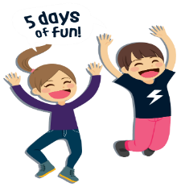

Please send in pictures of the following home assignments to my email martinezhaydee33@ yahoo.com on the following dates below. Make sure to include student’s name and number.

week 3/16/20 – 3/20/20 on Monday, 4/6/20
- Monday – Thursday: words to know/ Reading – TB pgs. 150 – 151/WB pgs. 52-53
- Friday: Comprehension Skills TB pgs. 144-145

week 3/23/20 – 3/27/20 on Tuesday, 4/7/20
- Monday – Thursday: Reading comprehension questions
- Friday: Story Events: Plot

Week 3/30/20 – 4/3/20 on Wednesday 4/8/20
- Worksheets A good Friend VS Bad Friend/ Friendship word search puzzle/ A Group of Friends coloring page
- TB p. 153/ weebly/ agenda attachments
- Friendship Portrait

