Academia San Agustín y Espíritu Santo
_{De Sabana Grande}

Mrs. Martinez Weekly Agenda Subject to changes
English | Date | Class Assignment | 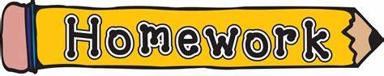 FOR STUDENTS!  Reinforce the learning at home every day.
W  E  E  K  #25 | Monday  January 20, 2020 | Martin Luther King, Jr.
Tuesday
January 21, 2020

 | Wednesday  January 22, 2020 | Happy & Healthy  Students are to enjoy a healthy snack to begin the celebration. Oatmeal cookie, & milk.  see NB | Materials needed in class on Tuesday, 1/28/20  see weebly: (bring to class)
 | Thursday  January 23, 2020 | My Food Vocabulary: Healthy Choices, Healthy Me!  - Students are to identify, read, listen, speak and identify write vocabulary words related to food to demonstrate comprehension. TB pgs. 102-103 | Vocabulary Comprehension  nutritious, portion, stomach, hungry, digest, unhealthy  H.W. WB pgs. 36-37
 | Friday  January 24, 2020 | My Food Vocabulary: Food Pyramid  - Students are to learn the five basic food groups and what each one consist of. see NB | Spelling Vocabulary  fruits, vegetables, grains, protein, dairy

