Academia San Agustín y Espíritu Santo
_{De Sabana Grande}

Mrs. Martinez Weekly Agenda Subject to changes
English | Date | Class Assignment | Home Connection  H.W.
W  E  E  K  #37 | Monday  April 13, 2020 | What are articles?  - Students are to read and understand articles within sentences. | *Parents are to read and explain the lesson to his/her child. Then have your child complete the Amazing Articles worksheet. See below  *Submit an image of the completed work via email.
 | Tuesday  April 14, 2020 | Pronunciation of the article  - Students are to learn the two ways to pronounce this article. | *Parents are to read, explain and complete the lesson.  *Submit an image of the completed worksheet via e-mail. See below
 | Wednesday  April 15, 2020 | Articles  - Students are to complete sentences using the articles a, an, and the when appropriate. TB pg. 78 | *Submit an image of the completed work via email.
 | Thursday  April 16, 2020 | Articles  - Students are to complete sentences using the articles a, an, and the when appropriate. WB. 28-29 | *Submit an image of the completed work via email.
 | Friday  April 17, 2020 | Amazing Articles  - Students are to complete sentences using the articles a, an, and the when appropriate. | *Submit a copy of the completed work via email.  See below

There are three articles in English . An article is a way of letting the listener or speaker know that a noun is either unspecific or specific.

Use a and an with singular nouns.
Use a before consonant or consonant sound Use an before vowel or vowel sound
The definite article is the word the. It’s used before singular and plural nouns when the noun is specific or particular.
- Let’s take a look at the example: During the long journey, the family played car games.

You can see that when we use the article ‘the’ that we are showing that we are talking about a specific day and also a specific family.
However, if we change the article, we can show that we are not talking about a specific journey or family.
- Take a look at the example now: During a long journey, a family can play car games.

Complete the Amazing Articles worksheet below.

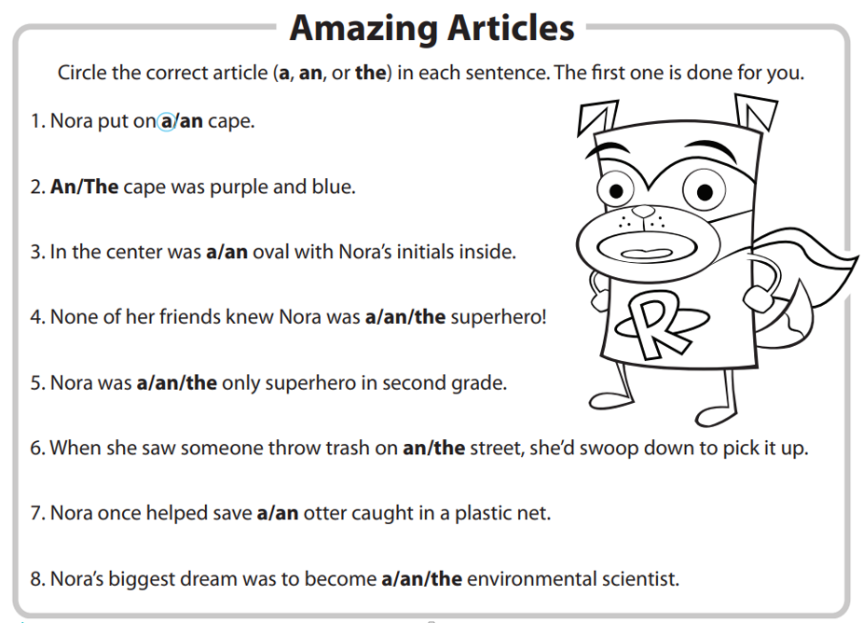

Tuesday, April 14, 2020
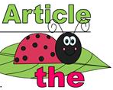
There are two ways to say

There is a general rule for knowing which pronunciation to use.
- If the word following ‘the’ starts with a consonant sound, you pronounce ‘the’ as ‘thuh’.
- If the word following ‘the’ starts with a vowel sound, you pronounce ‘the’ as ‘thee’
Let’s practice: Circle the correct pronunciation for each phrase.

- the uniform thuh thee 5. the hospital thuh thee

- the man thuh thee 6. the idea thuh thee

- the old school thuh thee 7. the answer thuh thee

- the elephant thuh thee 8. the pencil thuh thee

Following the rules for articles have your child fill-in which article completes each sentence?

.
- I go to ____________ private school.
- Please inform me about __________ next exam.
- Can you tell me _________interesting story?
- Do you know _________________ good dentist?
- Please tell me _______________ directions to the beach.
- I am going to ___________ park after school.
- I saw _______________raccoon in my backyard.
- We saw _________great basketball game.
- I would love to tell you _________secret.
10. Can you take me to __________doctor?
11. We will go to _________movies today.
12. Do you know ______ leader of our group?
13. I want to see ______elephant in the wild.

