Academia San Agustín y Espíritu Santo
_{De Sabana Grande}

Mrs. Martinez Weekly Agenda Subject to changes
English | Date | Class Assignment
W  E  E  K  #38 | Monday,  April 20, 2020 | Indefinite Articles: Vocabulary Matching  - Students are to choose the correct ‘a’ or ‘an’ for each of the words. Then match the words with the pictures.  DON’T FORTGET TO PRONOUNCE THE ARTICLES A, & AN, CORRECTLY!  see below pg. 2-5 | Submit an image of the completed worksheet via email today before 5:00 o’clock in the afternoon.
 | Tuesday,  April 21, 2020 | Definite Article The  - Discuss with your child on how and when to use the word ‘the’ to show that you are referring to a specific item. see below pg. 3-5 | Submit an image of the completed worksheet via email today before 5:00 o’clock in the afternoon.
 | Wednesday,  April 22, 2020 | Definite Article The  - Discuss with your child on how and when to use the word ‘the’ to show that you are referring to a specific item. see below pg. 4-5 | Submit an image of the completed worksheet via email today before 5:00 o’clock in the afternoon.
 | Thursday  April 23, 2020 | Articles in My Neighborhood Story  - Students are to read and choose whether to use a, an, or the in the sentences. The worksheet features sentences with a neighborhood theme.  DON’T FORTGET TO PRONOUNCE THE ARTICLES A, AN, & THE CORRECTLY!  see below pgs. 5-5 | Submit an image of the completed worksheet via email today before 5:00 in the afternoon.
 | Friday,  April 24, 2020 | Article Pronunciation: A, An, The  - When reading the story students are to think about the sound, not the writing of the articles.

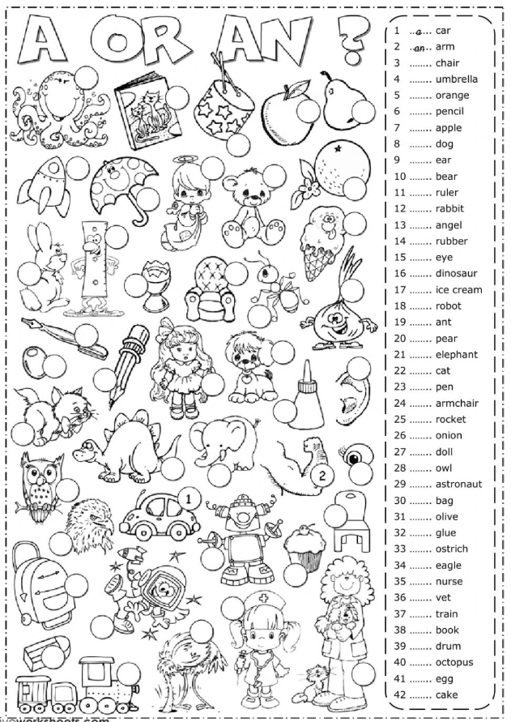
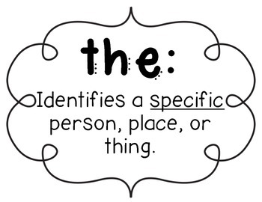

- Use the definite article “The” after you have talked about it the first time.
This is a dog. The dog is brown.

- . Use the definite article “The” when the person you are talking to already knows what are you talking about.
There is someone knocking at the door. 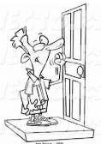 It must be the computer repairman.
I am going to the bank. 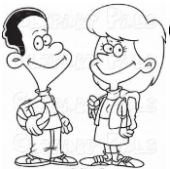

- We use definite article “the” before a singular or plural. Write the difinite article before the following words. Then under each item circle the correct pronunciation.
_______pencils | 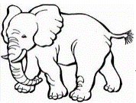  _____elephant | _______castle | 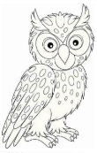 _____owls
thuh thee | thuh thee | thuh thee | thuh thee

- Use the definite article “The” when you talk about general places in nature like the lake, the mountains, the ocean, the beach etc.

Let’s go to the beach. I like to camp in the mountains.

Use the definite article when you are talking about something that there is only one of and everyone knows about it. WE NEVER SAY a sun, a moon, an earth, and a sky. We always say the sun, the moon, the earth, the sky, the world, the rain etc. (DONT FORTGET TO PRONUNCE THE WORD THUH/THEE CORRECTLY!)

How many people are there on the (thee) earth? The (thuh) sky is so beautiful today.

Let’s practice indifinite and definite articles. Can we say…

- the earth? Yes No 6. an apples? Yes No
2. a dogs? Yes No 7. the moon? Yes No
3. a man? Yes No 8. an owl? Yes No
4. an igloo? Yes No 9. an beach? Yes No
5. a lake? Yes No 10. a sun? Yes No
My Neighborhood
Choose the correct article (a, an, or the) to complete the paragraph.

My neighborhood is (a, an, the) very interesting place. My home is located in (a, an, the) apartment building downtown, near many stores and offices. There is (a, an, the) small supermarket across (a, an, the) street where my family likes to go shopping. There is also (a, an, the) post office and (a, an, the) bank near our home. In our neighborhood, there is (a, an, the) small, green park where my family likes to have picnics on weekends and holidays. There is (a, an, the) small pond in (a, an, the) park, and there are many ducks in (a, an, the) pond. We like to invite our friends when we go there, and we always have (a, an, the) great time! In addition, there is (a, an, the) elementary school close to our home where my little brother studies in (a, an, the) third grade. There are so many things to see and do in my neighborhood, and that’s why I like it! It’s really (a, an, the) great place!
(145 words)

