Academia San Agustín y Espíritu Santo
_{De Sabana Grande}

Mrs. Martinez Weekly Agenda Subject to changes
English | Date | REVIEW FOR FINALS
W  E  E  K  #42 | Monday  May 18, 2020 | Making Connections: The City Mouse and the Country Mouse  - Students are to listen and watch a short story for comprehension skills.  Town Mouse and Country Mouse- animated children’s story book | 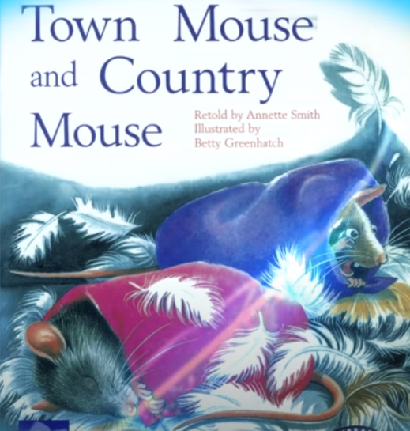(5 min. & 54 sec. video)
 | Tuesday  May 19, 2020 | Story Elements  - Students are to listen to the story again to know the title, setting and characters in the story. | Assessment: Where do you live?  Submit Live Audio Today
 | Wednesday  May 20, 2020 | What’s the difference between city and country?  - Students are to complete the worksheet below to learn the differences. | Complete and color the worksheet below
Thursday
May 21, 2020

Friday
May 15, 2020

What’s the difference between city and country?
- In the city (Urban) we can see__________________, ____________________, _______________________, ___________________, and________________.

- In the country (Rural) we can see __________________, ____________________, _______________________, ___________________, and ________________.

- Label where each mouse live. Then color.
_________________________(_________________________) | _________________________(_________________________)
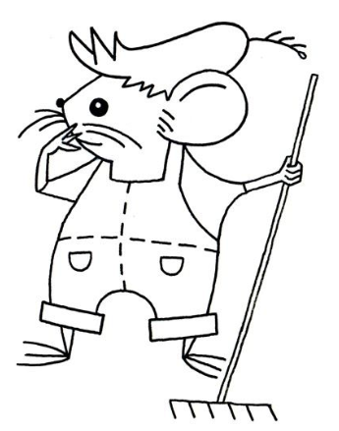 | 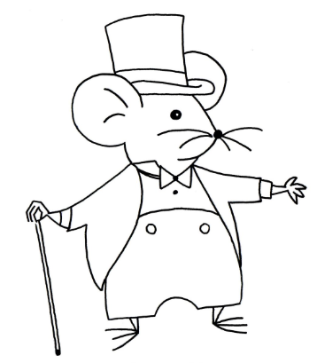

Review checklist
Theme: Our Community
- Community Helper Vocabulary TB pgs. 174-175/WB pgs. 62-63
- Types of community: Hands on activity worksheets 5/13/20 -TB p. 179
- Town Mouse and Country Mouse Comprehension Skills:
- Story Elements
Title, Setting, Characters
- True or False

